CAST IRON CHARLIE

Questions for Dad
Facts only the family can confirm — for the documentary and family archive
For: Charles Mitchel Sorensen
Prepared by: Chris Sorensen — March 2026

Each question has space for your answer. Where relevant, the photograph in question is shown alongside it. No answer is too short or too uncertain — “I don’t know” is useful too.

1 — Biographical Records to Confirm
These are specific facts where different sources disagree. Getting these right matters for the film and for the archive.

Q1 What was Charles Emil Sorensen’s exact date of death? Wikipedia says August 28, 1968. Find a Grave says August 11, 1968. Which is correct?  ▶ Why it matters: The film cannot get this wrong. A death certificate or newspaper obituary would settle it definitively. | Dad’s answer:

Q2 Was Charles Emil born September 7 or September 27, 1881? Most sources say September 7. One Danish-American calendar says the 27th.  ▶ Why it matters: Small but a film fact. September 7 is assumed unless the family confirms otherwise. | Dad’s answer:

Q3 How old was Charles Emil when the family emigrated from Copenhagen? One source says he arrived aged ~2 (around 1883). Another says aged 4 (around 1885).  ▶ Why it matters: The year affects the immigration narrative in the film’s opening act. A ship manifest would confirm it. | Dad’s answer:

Q4 Can you confirm the full family line from Charles Emil down to you and Chris? Who was his son or daughter, and how do we get to Charles Mitchel Sorensen?  ▶ Why it matters: The generational line is a gap in the archive. The film’s closing chapter depends on getting this exactly right. | Dad’s answer:

Q5 What was Helen Sorensen’s full maiden name and background? Where was she from originally?  ▶ Why it matters: Two yachts were named for her. Her story is woven through the film — the Helene launch photographs even show her at the christening. | Dad’s answer:

2 — Properties and Places
Charles Emil held significant properties across multiple states and in Cuba. Some are documented; others exist only in family memory.

Q6 Do you know the address or location of the Grosse Pointe estate? Any photographs, memories, or stories about it?  ▶ Why it matters: A major personal property during the Ford years. Not yet located in the archive. | Dad’s answer:

Q7 The St. Clair River summer home near Algonac — do you know the address or any details? The Helene II was registered to Algonac as her home port.  ▶ Why it matters: The Helene II’s home port. Algonac is confirmed; the specific property address is not. | Dad’s answer:

Q8 The Miami Beach winter home — do you know the address? His funeral service was held at the Community Church in Miami Beach. He is buried at Woodlawn Park North, Miami.  ▶ Why it matters: Confirms the retirement geography and connects to the burial location already confirmed in the archive. | Dad’s answer:

Q9 CESOR Farm — a 2,000-acre farm named for Charles Emil (Charles Emil SORensen) where he personally tested the civilian Jeep prototype before joining Willys-Overland. Do you know where it was located?  ▶ Why it matters: A significant undocumented asset. The farm name and Jeep-testing story are confirmed by sources — the location is not. | Dad’s answer:

Q10 The US Virgin Islands retirement property — do you know anything about this? Where, when he acquired it, how often he went there?  ▶ Why it matters: Mentioned in sources as a retirement location alongside Florida. No details confirmed. | Dad’s answer:

Q11 The Cuba land holdings — do you know what was there, where it was located, when he acquired it, and when it was seized by the Castro government?  ▶ Why it matters: A striking biographical detail. The man who built the Arsenal of Democracy had his land taken by Castro. Worth documenting fully. | Dad’s answer:

3 — The Yachts
Two yachts, both named Helene — both named for Helen Sorensen. The first still exists on the Detroit River. The second is at the bottom of the English Channel. The photographs below show the first Helene as she is today.

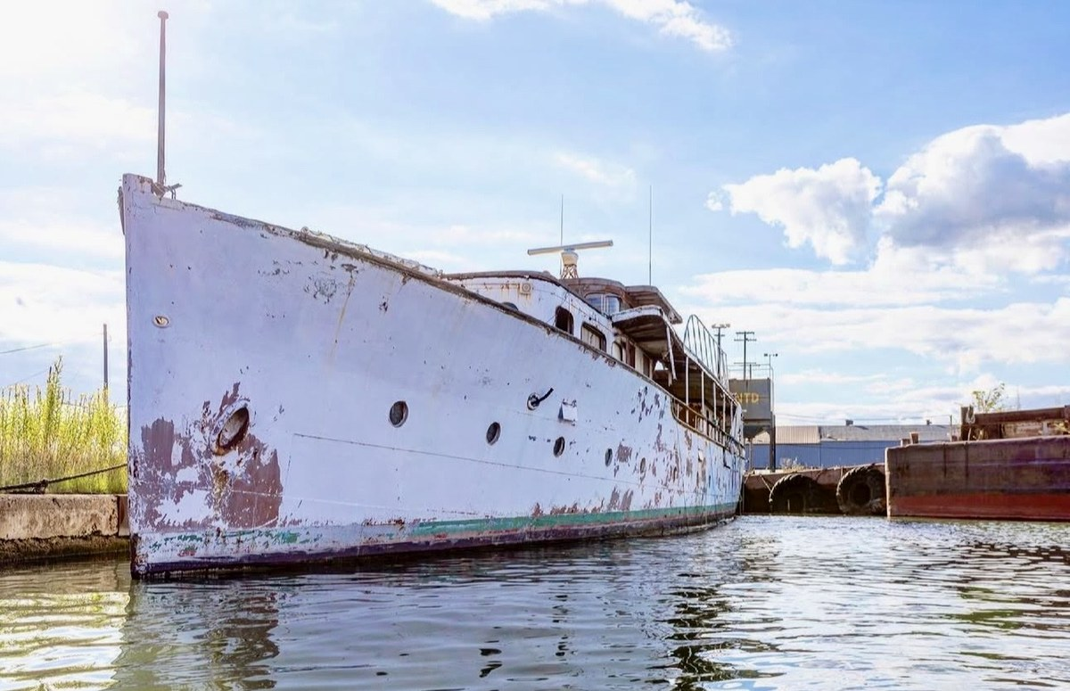  M/Y Helene I — port broadside, Nicholson Terminal, Detroit River | 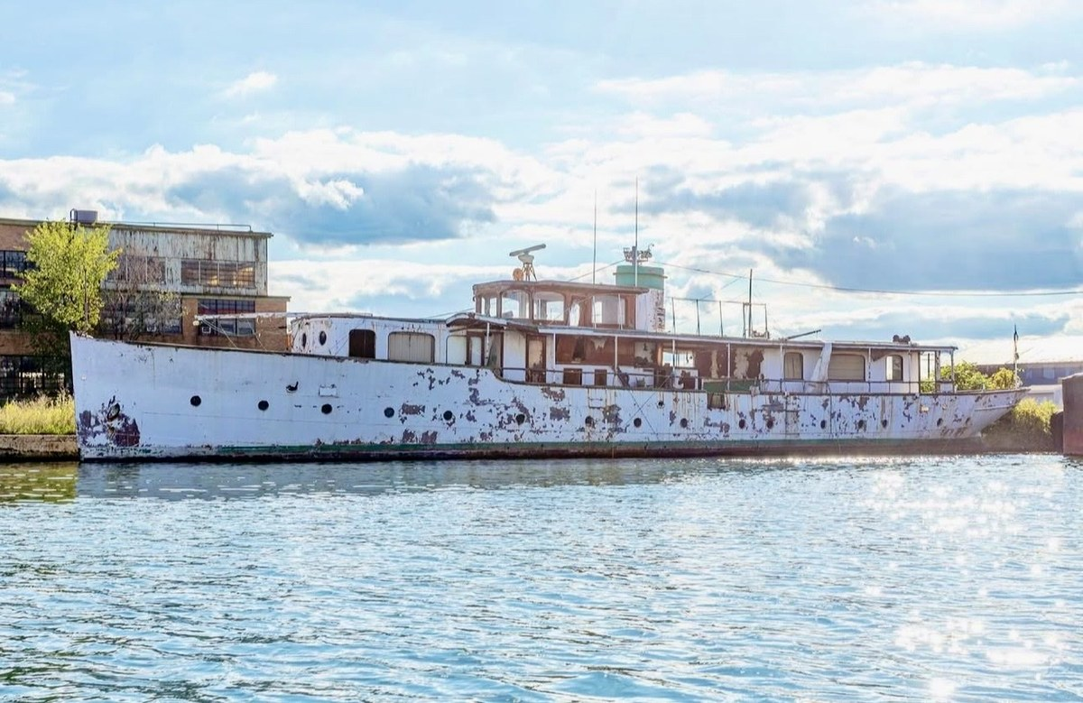  Bow-on view — steel hull intact, open to weather

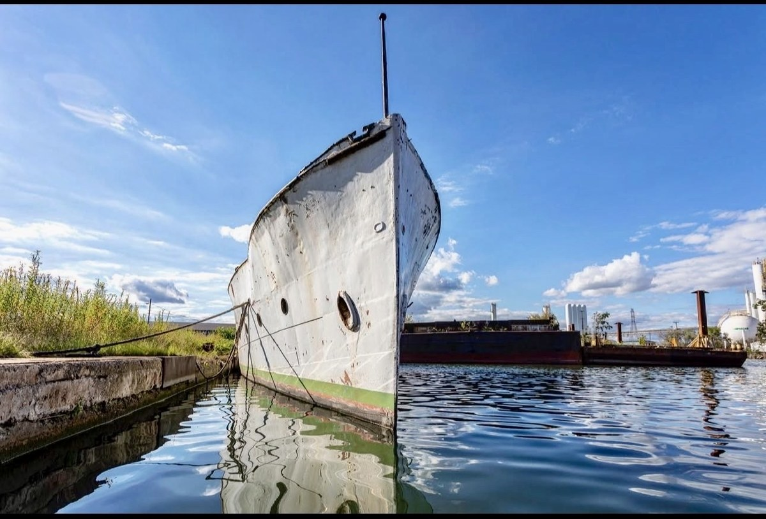  Midship detail — open superstructure, peeling paint | 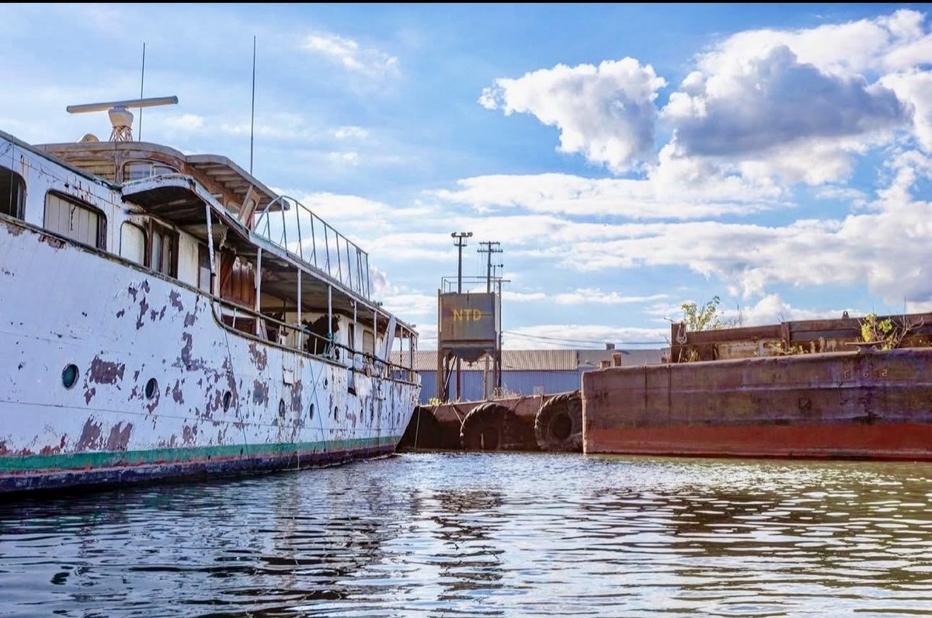  Sun-flare silhouette — NTD terminal building visible in background

Q12 Who took these photographs of the first Helene at the Nicholson Terminal? Do you know when they were taken?
▶ Why it matters: Professional-quality images central to the film’s visual strategy. Rights need to be cleared for production use.

Dad’s answer:

Q13 Do you have any memory or family stories about either Helene yacht — time spent aboard, stories passed down from Charles Emil or others in the family?
▶ Why it matters: Personal testimony about the yachts adds a human dimension no archive can supply.

Dad’s answer:

Q14 A handwritten note inside the Helene II specification document reads “Helene — Detroit II” with comparative dimensions. Do you know if a smaller second vessel was ever built or planned?
▶ Why it matters: A possible third Helene — perhaps a tender or runabout. Family memory is the only way to resolve this.

Dad’s answer:

4 — Photographs
Several photographs in the family collection have unknown sources or unconfirmed details. These questions help establish provenance and context for production use.

Q15 This portrait of Charles Emil — do you know where it came from, when it was taken, or what he is holding in his hands?  ▶ Why it matters: The strongest individual portrait in the collection. Likely a title-card image for the film. Provenance is needed before production can use it. | 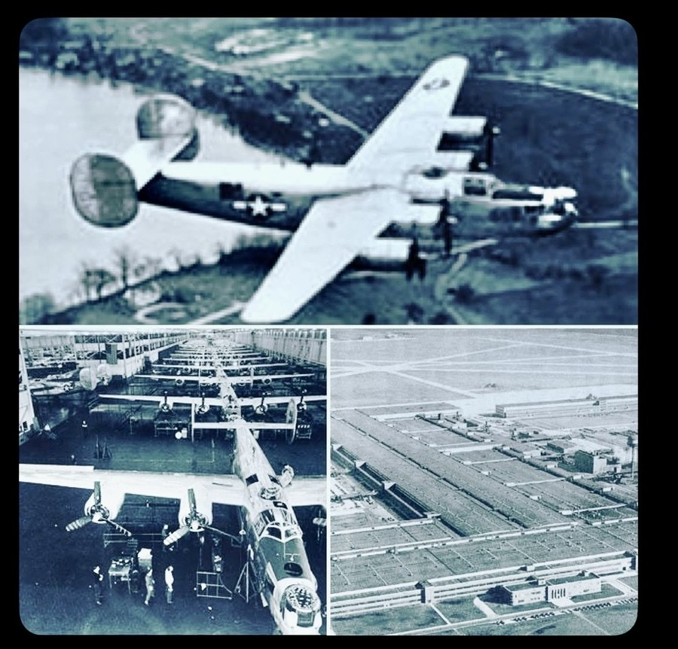  Charles Emil Sorensen — source unknown

Q16 This photograph shows Sorensen (centre, civilian suit) with military personnel on an airfield, circa 1942. The Historic Images watermark confirms it is a press photograph available for purchase — but the product number is not yet located. Do you know anything about this image or this occasion?  ▶ Why it matters: A third Historic Images press print. Any context about who the other figures are, or what the occasion was, would significantly increase its value to the film. | 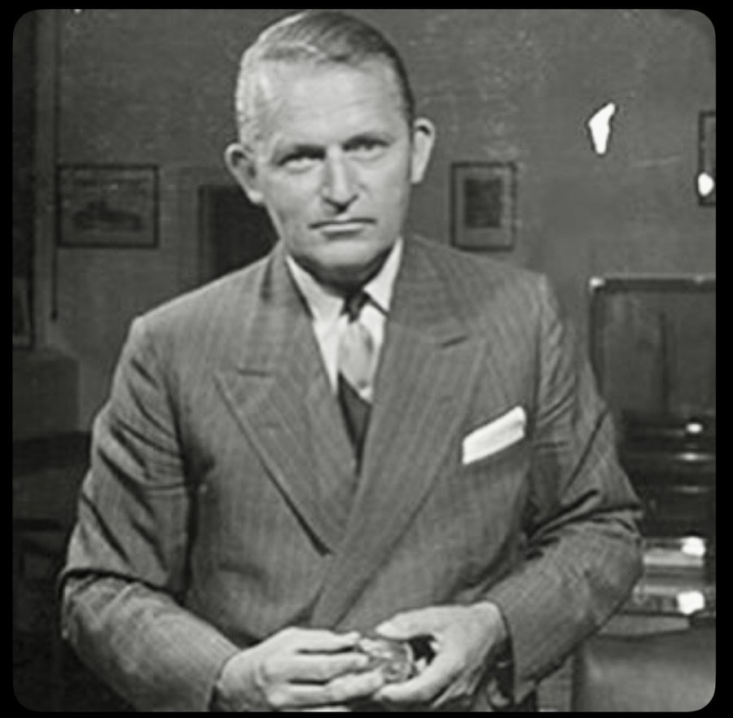  Sorensen with military personnel, c.1942 (Historic Images)

Q17 This is President Roosevelt, Henry Ford, and Charles Sorensen (centre-rear) touring Willow Run on September 18, 1942 — confirmed by The Henry Ford collection. Eleanor Roosevelt was also present on this visit. Is there any family memory or story connected to this day?  ▶ Why it matters: One of the most significant photographs in the public record of the war. Any family dimension to this event — however small — would be valuable. | 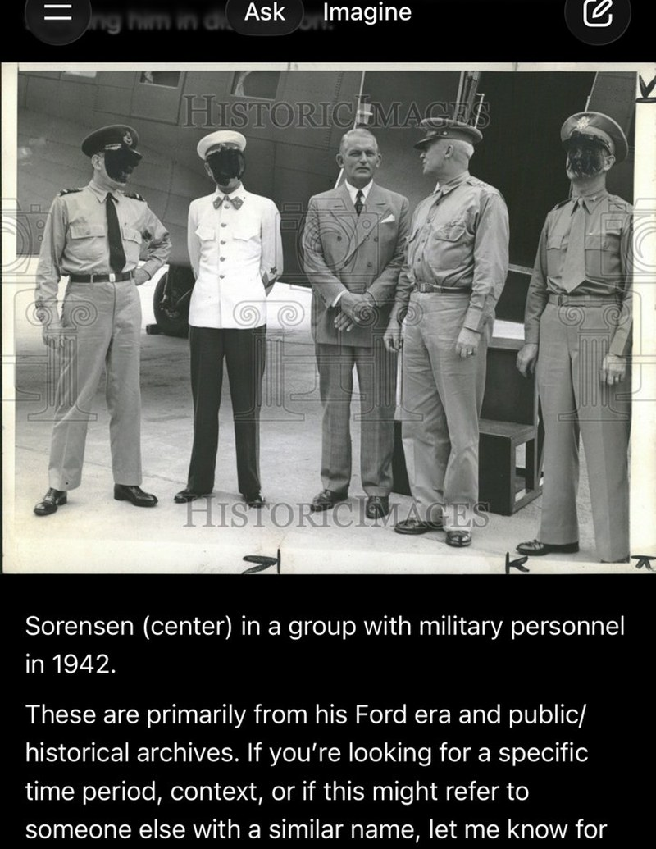  Roosevelt, Ford, and Sorensen, Willow Run, September 18, 1942 (U.S. Navy / The Henry Ford, THF93105)

Q18 This photograph shows a worker lettering “Ford’s 8,000th Liberator” on the nose of a B-24. Sorensen’s retirement took effect March 13, 1944 — just as Willow Run was hitting full stride. He conceived and built the machine that reached 8,000 bombers, but wasn’t there when the number was painted on the nose. The achievement was his; the celebration was someone else’s. Do you know the source of this photograph?  ▶ Why it matters: A poignant image: the achievement was Sorensen’s, the celebration was someone else’s. Confirming the source enables the film to use it. | 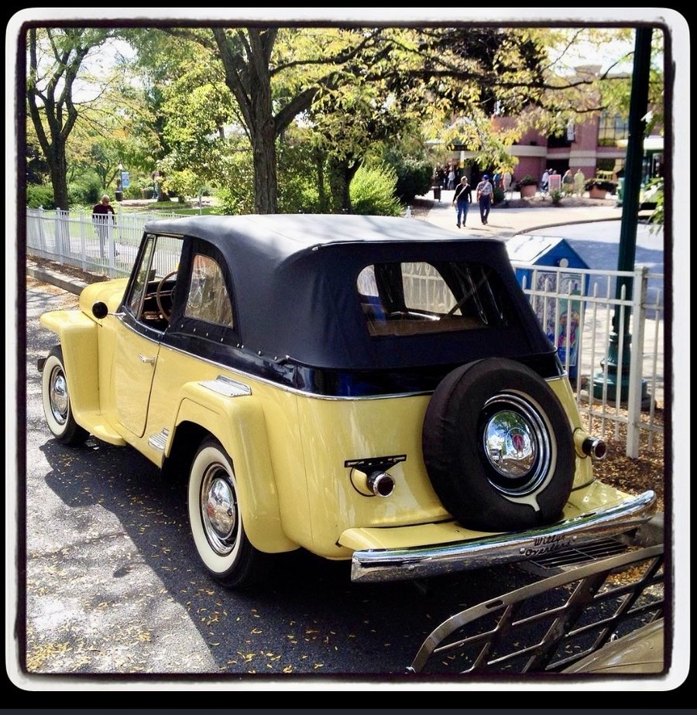  “Ford’s 8,000th Liberator” — source to be confirmed

Q19 Are there any other photographs in the family’s possession that haven’t been shared yet — particularly of Charles Emil at Ford, at Willys, with family members, or at any of his properties?  ▶ Why it matters: The most open-ended visual question. The family archive may hold material no researcher has ever seen. | Dad’s answer:

Q20 This is a Willys Jeepster — one of the vehicles developed under Sorensen’s presidency at Willys-Overland. He overruled designer Brooks Stevens and insisted on a four-passenger version rather than a two-seater. Is there any family connection to the civilian Jeep era at Willys?  ▶ Why it matters: The Willys chapter is under-documented in the archive. Any family memory of this period would help. | 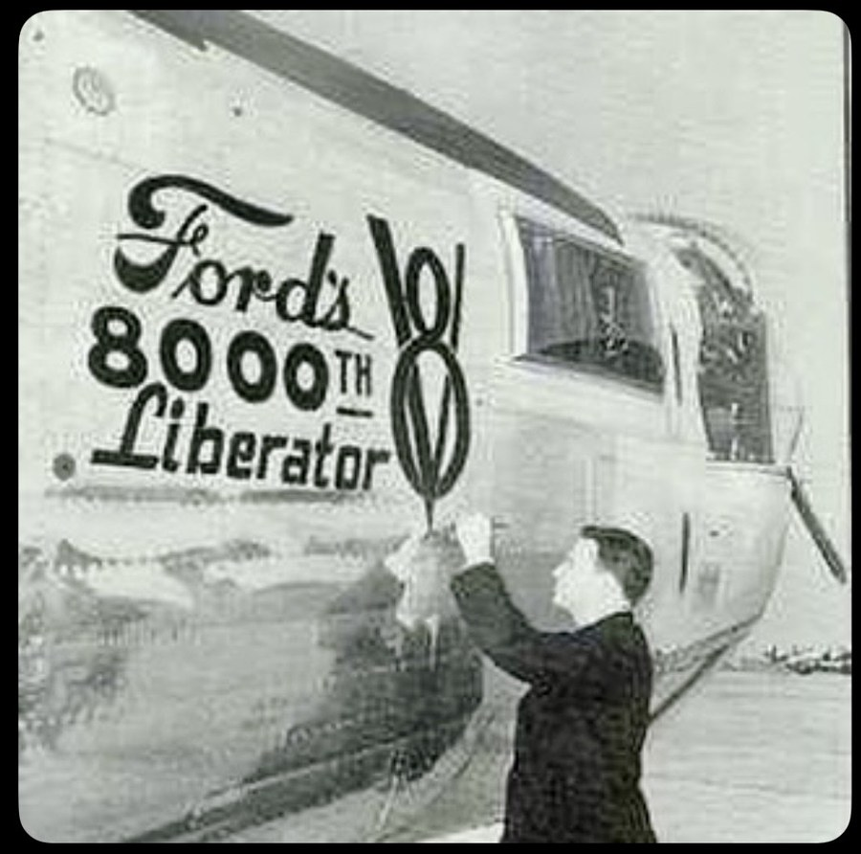  Willys Jeepster — developed under Sorensen’s leadership at Willys-Overland

5 — Personal and Family Memory
These questions go beyond the documentary record. They ask for living memory — stories, impressions, and things said within the family about Charles Emil. These answers cannot come from any archive.

Q21 Did your father or other family members ever talk about Charles Emil personally — what he was like as a man, a grandfather, a presence in the family?
▶ Why it matters: The film needs a human portrait, not just an industrial one. Family memory is the only source for this.

Dad’s answer:

Q22 Was Charles Emil’s relationship with Henry Ford ever discussed in the family? The research now shows the full picture: Sorensen championed Henry Ford II’s rise, sided with Edsel against both the elder Henry and Harry Bennett, and lost his position partly as a result. Henry Ford II’s first act on taking control was to fire Bennett — in a confrontation where Bennett reached for a gun. Sorensen then received a generous retirement package from Henry II. Did anyone in the family talk about any of this — about Ford, about Edsel, about the way it ended?
▶ Why it matters: Sorensen’s memoir is measured on the personal cost. Family memory may be more candid about how he actually felt.

Dad’s answer:

Q23 Harry Bennett — Ford’s enforcer, a man with organised crime connections who broke into Edsel Ford’s own home and smashed his liquor stock while the family was away. Sorensen opposed Bennett throughout and blamed him heavily for Edsel’s early death. Was Bennett ever mentioned in the family? Did Charles Emil ever speak about him — with anger, with contempt, or otherwise?
▶ Why it matters: Bennett is the villain of the Ford chapter. Any family memory of how Sorensen spoke about him would be significant — the memoir is damning but restrained. Private conversation may have been less so.

Dad’s answer:

Q24 Did Charles Emil ever speak within the family about the assembly line — about whether he or Ford deserved the credit for inventing it? Did he feel the historical record was unjust to him?
▶ Why it matters: The central question of the entire film. Any family testimony on this is gold.

Dad’s answer:

Q25 Did the family have any contact or correspondence with the Danish royal family beyond the two decoration ceremonies (1930 and 1937)? Did Charles Emil ever return to Denmark?
▶ Why it matters: The March 2026 letter to King Frederik X is framed as a renewal of a historic bond. Any earlier correspondence or visits would deepen that narrative.

Dad’s answer:

Q26 Is there anything about Charles Emil — a story, a saying, a habit, a decision, something he did or said — that has been passed down in the family and that you think the documentary absolutely must include?
▶ Why it matters: The most important question on this list. Whatever the answer is, it will be something no archive holds.

Dad’s answer:

Add any additional answers, memories, or new questions directly to this document.
Cast Iron Charlie — Sorensen Family Documentary Project — March 2026

